AI LAB ASSIGNMENT 7.3:

**NAME:M.VARSHITHA**

**HALLTICKET NO:2403A52342**

TASK 1:Paste a function with a missing colon (add(a, b)), and let AI fix the syntax error.

Corrected code:

EXPLANATION:

TASK 2:

Identify and fix a logic error in a loop that causes infinite iteration.

Corrected code:

EXPLANATION:

TASK 3:

Debug a runtime error caused by division by zero. Let AI insert try-except.

Corrected code:

EXPLANATION:

TASK 4:

Provide a faulty class definition (missing self in parameters). Let AI fix it

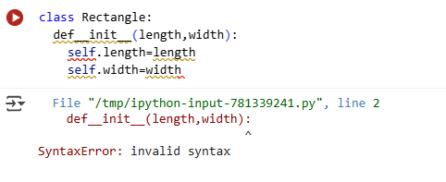

Corrected code:

EXPLANATION:

TASK 5:

Access an invalid list index and use AI to resolve the Index Error.

Corrected code:

EXPLANATION:

